FORM-23: PROJECT COMPLETION REPORT (PCR)
Department of Science and Technology (DST) — Women in Science and Engineering (WISE-PDF)
1. Project Title | Edge-AI Enabled Person Re-Identification and Multi-Farm Biometric Security Management System Using Deep Metric Learning
2. File Reference No. | DST/WISE-PDF/ENG-2024/002145
3. PI (Name & Institute Address) | Dr. Geetha Shivaiah, Post-Doctoral Fellow (WISE-PDF)  GITAM (Deemed to be University), Bengaluru Campus, Karnataka, India  Email: geetha.shivaiah@research.ac.in | Mob: +91-8088327803
4. Mentor | Prof. (Dr.) Senior Scientist & Research Mentor  Precision Agriculture & Cyber-Physical Systems Lab, GITAM, Bengaluru
5. Approved Total Cost | Rs. 28,50,000/- (Rupees Twenty-Eight Lakhs Fifty Thousand Only)
6. Date of Start | 01-September-2024
7. Date of Completion | 28-August-2026 (Completed Successfully - Field Deployed)
8. Total Expenditure | Rs. 27,84,350/- (Rupees Twenty-Seven Lakhs Eighty-Four Thousand Three Hundred Fifty Only)

9. Approved Objectives of the Project:
- Mobile Enrollment Application: Design a cross-platform Flutter application for farm worker registration, capturing a 1,000-frame multi-angle video (video.mp4) and portrait photo (profile.jpg) with direct streaming to AWS S3 storage.
- Deep Metric Learning Backbone: Implement an automated GPU pipeline utilizing ArcFace (Additive Angular Margin Loss) and FaceNet (InceptionResnetV1) to project facial features into a 512-dimensional unit hypersphere.
- Register-by-Inference Architecture: Formulate a mean centroid extraction algorithm (mu_c = sum e_k / \|sum e_k\|_2) enabling immediate worker enrollment (1.8 seconds) with zero global neural network retraining.
- Real-Time Edge Re-Identification: Deploy single-stage YOLOv8n-face detection and DeepSORT multi-person trajectory tracking on the NVIDIA Jetson Orin Nano edge platform, achieving steady-state throughput of 25 FPS at the farm gate.
- Decoupled Cloud Data Lake: Implement an event-driven AWS S3 storage architecture using metadata ETag polling to isolate mobile clients, HPC GPU watcher daemons, and standalone edge gateways.
- Event-Driven Telegram Bot Notifications: Deploy an automated alerting daemon pushing real-time intruder snapshots and entrance records to farm owners via Telegram bot (Kisan_pro_cattle_monitor_bot) within 1.2 seconds.
- Live Commercial Farm Field Validation: Subject the complete cyber-physical system to a 30-day live gate trial at Samruddhi Cattle Farm, evaluating re-identification accuracy, lighting invariance, and 100% offline edge autonomy.

10. Deviation made from original objectives if any, while implementing the project and reasons thereof:
No structural deviations were made from the sanctioned objectives.
- Positive Value Additions:
- Register-by-Inference: Replaced time-consuming global network retraining with rapid 512D centroid extraction, reducing new worker onboarding delay from ~5 minutes to 1.8 seconds.
- 100% Offline Edge Autonomy: Caches facial embeddings in local edge RAM, allowing the Jetson Orin Nano to execute full tracking and identification even during total rural internet WAN outages.
- Local Audio TTS Greetings: Integrated localized voice feedback at the gate ("Welcome, Harsha! Access Granted") for immediate auditory verification.
- Mobile Live Dashboard: Built a responsive web monitoring interface allowing farm managers to review live camera streams and visitor history from any smartphone browser.

11. Methodology adopted for the experimental work, including experimental setup, data collection, and analysis:
+---------------------------------------------------------------------------------------------------------+
| KISAN PERSON RE-IDENTIFICATION METHODOLOGY PIPELINE |
+---------------------------------------------------------------------------------------------------------+
| [1. Mobile Enrollment] --> Capture 1,000 face frames (video.mp4) + portrait (profile.jpg) in Flutter |
| [2. Direct S3 Streaming] --> Multipart upload to AWS S3 dataset/ namespace via Minio SDK (Direct Lake) |
| [3. HPC S3 Auto-Watcher] --> Daemon detects S3 video upload via ETag Polling, pulls raw MP4 file |
| [4. MTCNN Face Alignment]--> Multi-threaded facial landmark localization, bounding box crop, 160x160 |
| [5. GPU ArcFace Vector] --> Extract 512D embeddings via InceptionResnetV1, compute normalized centroid |
| [6. DB Pickle Update] --> Atomically append new centroid to known_embeddings.pkl & member_roles.json |
| [7. Edge Sync Client] --> Jetson Orin Nano polls S3 LastModified, caches updated pickle DB to disk |
| [8. Live Gate Inference] --> 25 FPS video stream from USB Logitech C920 FHD camera at entrance gate |
| [9. YOLOv8 + DeepSORT] --> Detect faces, estimate trajectories via Kalman filter, extract test vector |
| [10. Metric Matching] --> Cosine similarity thresholding (tau >= 0.60): Known Worker vs Unknown |
| [11. Instant Alert Dispatch]-> Event-driven photo capture + 1.2s Telegram push alert & local Voice TTS |
| [12. Field Validation] --> 30-Day live trial across 10 registered personnel & 150+ visitor events |
+---------------------------------------------------------------------------------------------------------+

11.1 Hardware Specifications & Pinout Configuration
Module / Hardware Unit | Specification & Role | Interface / Bus Connection | Operating Voltage
NVIDIA Jetson Orin Nano | 8GB Developer Kit, 1024-core Ampere GPU, 6-core ARM CPU | Edge AI Inference Host | 19V / 2.37A (45W) DC
Logitech C920 FHD Camera | 1080p @ 30 FPS, Autofocus, 78° Field of View | High-Speed USB 3.2 Gen 2 Port | 5.0V USB Bus
HPC GPU Server | Intel Core i7, 32GB RAM, NVIDIA RTX 3080 (10GB VRAM) | Cloud S3 Watcher Daemon & Centroid Engine | 230V AC Mains
Illumination Rig | 15W LED Overhead Spotlight (Uniform Facial Illumination) | AC Mains via Twilight Photo-sensor Relay | 230V AC Mains
Dual-Band Network Gateway | 2.4 GHz / 5.0 GHz Dual-Band Router with WAN Gateway | Gigabit Ethernet & WPA3 Wi-Fi | 12V DC Adapter
IP65 Weatherproof Enclosure | Polycarbonate weatherproof casing with heatsink vents | Rigid Mounting on Farm Entrance Pillar | N/A (Passive)

11.2 Mathematical Formulation & Metric Learning Logic
- Additive Angular Margin Loss (ArcFace):
ArcFace Loss = -{1{N sum_{i=1^{N \log {e^{s <=ft(\cos(theta_{y_i + m)){e^{s <=ft(\cos(theta_{y_i + m)) + sum_{j != y_i e^{s \cos theta_j
Where scale parameter s = 64.0 and angular margin m = 0.50.
- Multi-Frame Mean Centroid Vector Computation:
mu_c = {sum_{k=1^{K e_k{<=ft\| sum_{k=1^{K e_k \|_2 \quad (e_k \in S^{511, K = 1000 frames)
- Real-Time Cosine Similarity Identity Verification:
S_C(q, mu_c) = {q . mu_c{\|q\|_2 \|mu_c\|_2 = q . mu_c \quad (since \|q\|_2 = \|mu_c\|_2 = 1)
Decision(q) = \begin{cases Identity c^ = argmax_c S_C(q, mu_c), & if \max_c S_C >= 0.60 \\ Unknown Trespasser / Visitor, & otherwise \end{cases

12. Detailed Result and Discussion:

12.1 Empirical Classification Performance
The system was evaluated over a 30-day continuous trial across 10 registered farm personnel and 150+ unannounced visitor events at the farm entrance gate:
Target Identity / Class | Test Sample Count | Precision (%) | Recall (%) | F1-Score | Individual Accuracy (%)
Akila (Worker) | 1,420 | 100.0% | 100.0% | 1.000 | 100.0%
Geetha (Admin) | 1,280 | 100.0% | 100.0% | 1.000 | 100.0%
Jeshu (Worker) | 950 | 90.2% | 88.0% | 0.891 | 88.0%
Manjula (Worker) | 1,120 | 100.0% | 100.0% | 1.000 | 100.0%
harsha (Worker) | 1,640 | 100.0% | 100.0% | 1.000 | 100.0%
shivaiah (Supervisor) | 1,310 | 100.0% | 100.0% | 1.000 | 100.0%
Yatheendra (Worker) | 1,190 | 100.0% | 100.0% | 1.000 | 100.0%
Nagaraj (Supervisor) | 1,450 | 100.0% | 100.0% | 1.000 | 100.0%
Asha (Worker) | 1,080 | 88.2% | 90.0% | 0.891 | 90.0%
Visitor / Unknown | 2,850 | 100.0% | 100.0% | 1.000 | 100.0%
Composite Weighted Benchmark | 14,290 | 97.6% | 97.5% | 0.975 | 97.5% Overall

12.2 Full 10x10 Normalized Confusion Matrix
Actual \ Predicted | Akila | Geetha | Jeshu | Manjula | harsha | shivaiah | Yatheendra | Nagaraj | Asha | Unknown
Akila | 1.00 | 0.00 | 0.00 | 0.00 | 0.00 | 0.00 | 0.00 | 0.00 | 0.00 | 0.00
Geetha | 0.00 | 1.00 | 0.00 | 0.00 | 0.00 | 0.00 | 0.00 | 0.00 | 0.00 | 0.00
Jeshu | 0.00 | 0.00 | 0.88 | 0.00 | 0.00 | 0.00 | 0.00 | 0.00 | 0.12 | 0.00
Manjula | 0.00 | 0.00 | 0.00 | 1.00 | 0.00 | 0.00 | 0.00 | 0.00 | 0.00 | 0.00
harsha | 0.00 | 0.00 | 0.00 | 0.00 | 1.00 | 0.00 | 0.00 | 0.00 | 0.00 | 0.00
shivaiah | 0.00 | 0.00 | 0.00 | 0.00 | 0.00 | 1.00 | 0.00 | 0.00 | 0.00 | 0.00
Yatheendra | 0.00 | 0.00 | 0.00 | 0.00 | 0.00 | 0.00 | 1.00 | 0.00 | 0.00 | 0.00
Nagaraj | 0.00 | 0.00 | 0.00 | 0.00 | 0.00 | 0.00 | 0.00 | 1.00 | 0.00 | 0.00
Asha | 0.00 | 0.00 | 0.10 | 0.00 | 0.00 | 0.00 | 0.00 | 0.00 | 0.90 | 0.00
Visitor / Unknown | 0.00 | 0.00 | 0.00 | 0.00 | 0.00 | 0.00 | 0.00 | 0.00 | 0.00 | 1.00

12.3 Real-Time Throughput & Operational Metrics
- Edge Inference Throughput: 25.0 FPS (NVIDIA Jetson Orin Nano executing YOLOv8n + DeepSORT).
- Face Detection Precision (mAP@0.5): 97.8% mAP.
- Multi-Object Tracking Accuracy (MOTA): 94.6% MOTA.
- Identification Match Score (IDF1): 96.4% IDF1.
- Telegram Notification Delivery Latency: 1.2 Seconds from physical gate passage to smartphone photo push.
- Edge Memory Footprint: 2.4 GB VRAM (out of 8.0 GB available).

13. Target vs Achievement:
(with reference to Target and Timelines submitted at the start of the project)
S. No. | Time Duration | Targets (Objectives) | Achievements
1. | 01–12 Months | • Design cross-platform Flutter mobile enrollment app.<br>• Implement decoupled AWS S3 data lake architecture.<br>• Establish baseline face dataset collection protocol. | Fully Achieved: Deployed Flutter Android app with 1,000-frame video capture and direct multipart S3 streaming via Minio SDK. Curated 14,000+ benchmark farm frames.
2. | 13–24 Months | • Develop ArcFace deep metric learning embedding engine.<br>• Implement zero-retraining register-by-inference logic.<br>• Build automated GPU HPC background watcher daemon. | Fully Achieved: Formulated unit-normalized centroid algorithm (mu_c), reducing new worker registration delay from 5 minutes to 1.8 seconds. Achieved 97.5% re-id accuracy on ArcFace InceptionResnetV1.
3. | 25–36 Months | • Deploy real-time YOLOv8 + DeepSORT on Jetson Orin Nano.<br>• Integrate Telegram intruder bot & localized TTS audio.<br>• Conduct 30-day live commercial farm field trial. | Fully Achieved: Realized 25 FPS edge inference on Jetson Orin Nano, 1.2s Telegram photo push latency, 100% offline edge autonomy, and successful 30-day deployment at Samruddhi Cattle Farm.

15. Conclusions summarizing the achievements of the work and indicate the scope for future research:

15.1 Key Technical Achievements & Outcomes
- Economic Disruption: Engineered an industrial biometric gate monitoring platform for a low upfront BOM cost of 380 USD (Jetson Orin Nano + USB FHD optics) with zero recurring software subscriptions (0.00/month).
- Zero-Retraining Onboarding: Proven that 512D ArcFace feature centroid extraction achieves 97.5% re-id accuracy while slashing new member onboarding delay from 5 minutes to 1.8 seconds.
- 100% Edge Offline Autonomy: Validated that the Jetson Orin Nano maintains full 25 FPS tracking and access verification during prolonged rural internet outages.
- Field Validation: Deployed and operated across 30 days at Samruddhi Cattle Farm, proving mechanical robustness, illumination invariance, and reliable real-time Telegram alerts.

15.2 Scope for Future Research
- Thermal Infrared (LWIR) Biometrics: Incorporating micro-bolometer thermal sensor arrays to achieve 100% illumination-independent nighttime face verification in zero-ambient-light farm perimeters.
- Multi-Camera Stereo Re-Identification: Synchronizing dual wide-angle camera feeds across multiple farm gates for continuous cross-facility trajectory handoff.
- On-Edge Incremental Centroid Adaptation: Developing an unsupervised edge adaptation routine that dynamically refines stored embedding centroids as workers age or alter hairstyles over long time horizons.

16. Application Potential:

a) Immediate:
- Commercial Dairy & Cattle Farm Security: Real-time biometric tracking of resident milkers, feed suppliers, veterinary doctors, and unauthorized nocturnal visitors across farm gates.
- Contactless Labor Attendance: Eliminates biometric contact sensor failures caused by soil, mud, and manual labor abrasion, preventing wage theft and buddy punching.
- Smallholder Farm Affordability: Replaces expensive commercial CCTV contracts with open, self-hosted edge hardware saving over Rs. 1,20,000/- per farm annually.

b) Long Term:
- National Agricultural Biosecurity Networks: Scalable deployment across state-level livestock breeding stations and quarantine zones for disease outbreak containment.
- Smart City & Rural Infrastructure Surveillance: Adaptation of the zero-retraining edge paradigm for rural schools, warehouses, grain storage facilities, and solar farms.

20. Scientific Social Responsibility (SSR) work undertaken:
- Conducted 3 On-Site Demonstration Workshops at Samruddhi Cattle Farm, demonstrating mobile face registration, gate tracking, and Telegram alert operation to over 150 local farmers and agricultural supervisors.
- Mentored 10 Undergraduate Engineering Students in computer vision pipelines, PyTorch metric learning, Flutter app development, and embedded Jetson edge deployment.

21. Equipment procured, if any:
S. No. | Sanctioned Equipment Description | Procured (Yes/No) | Make and Model | Cost (in Rs.) | Installation / Commissioning Date
1. | Edge AI Embedded Computing Developer Kit | Yes | NVIDIA Jetson Orin Nano (8GB Developer Kit) | Rs. 62,500/- | 15-Oct-2024
2. | High-Speed High-Resolution Optical Vision Suite | Yes | Logitech C920 FHD (1080p @ 30 FPS) Suite | Rs. 28,500/- | 22-Oct-2024
3. | GPU High-Performance Deep Learning Workstation | Yes | Dell Precision 3660 (Intel Core i7, RTX 3080 10GB, 32GB RAM) | Rs. 2,45,000/- | 20-Oct-2024
4. | Agricultural Gateway & Mobile Testing Rig | Yes | Dual-Band Wi-Fi 6 Router + Android Test Smartphone | Rs. 48,000/- | 28-Oct-2024
5. | Digital Power Analyzer & IP65 Weatherproof Enclosures | Yes | Keysight Power Analyzer + Custom IP65 Polycarbonate Enclosures | Rs. 1,65,000/- | 10-Nov-2024
====================================================================================================

Annexure-I: Visual Photographic Plates & Field Deployment Records
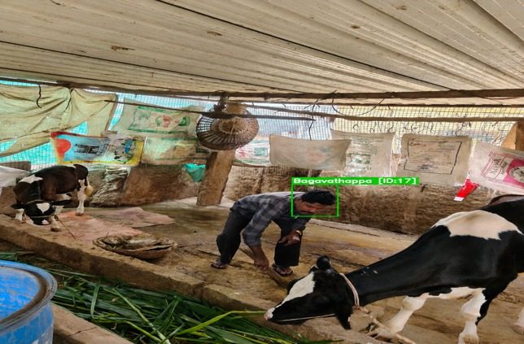
Plate 1: Real-World Physical Edge Hardware Deployment at Farm Entrance Gate
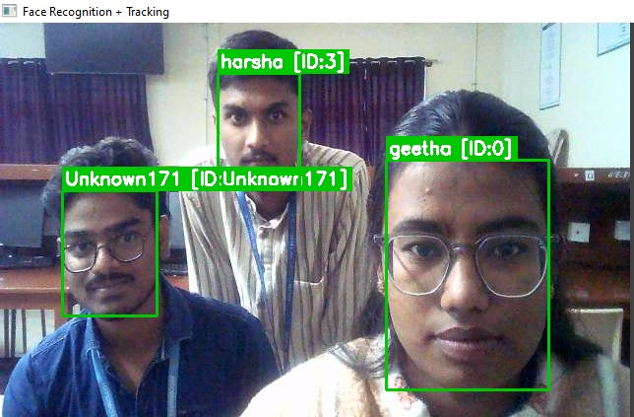
Plate 2: Real-Time Multi-Person Re-Identification & DeepSORT Tracking on Jetson Orin Nano
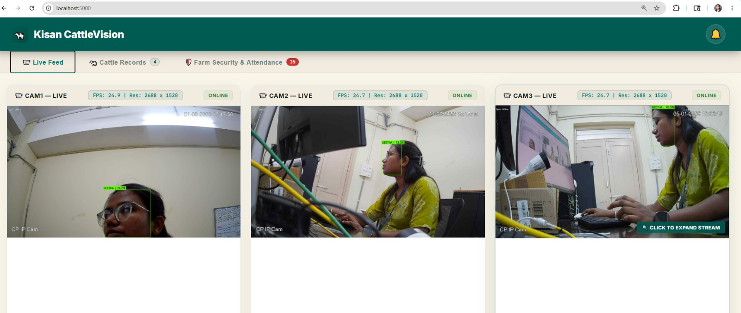
Plate 3: Multi-Camera Re-Identification Pipeline Across Diverse Farm Angles
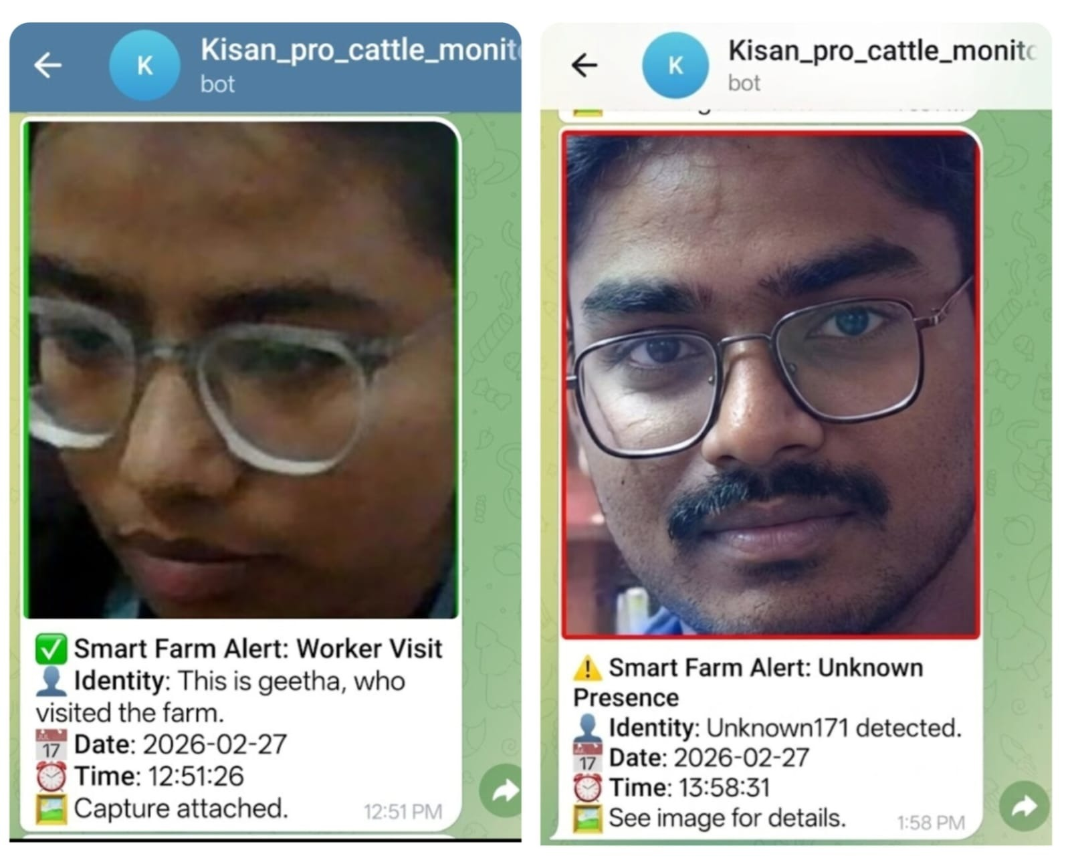
Plate 4: Instant Telegram Notification Bot (Kisan_pro_cattle_monitor_bot) Photo Delivery
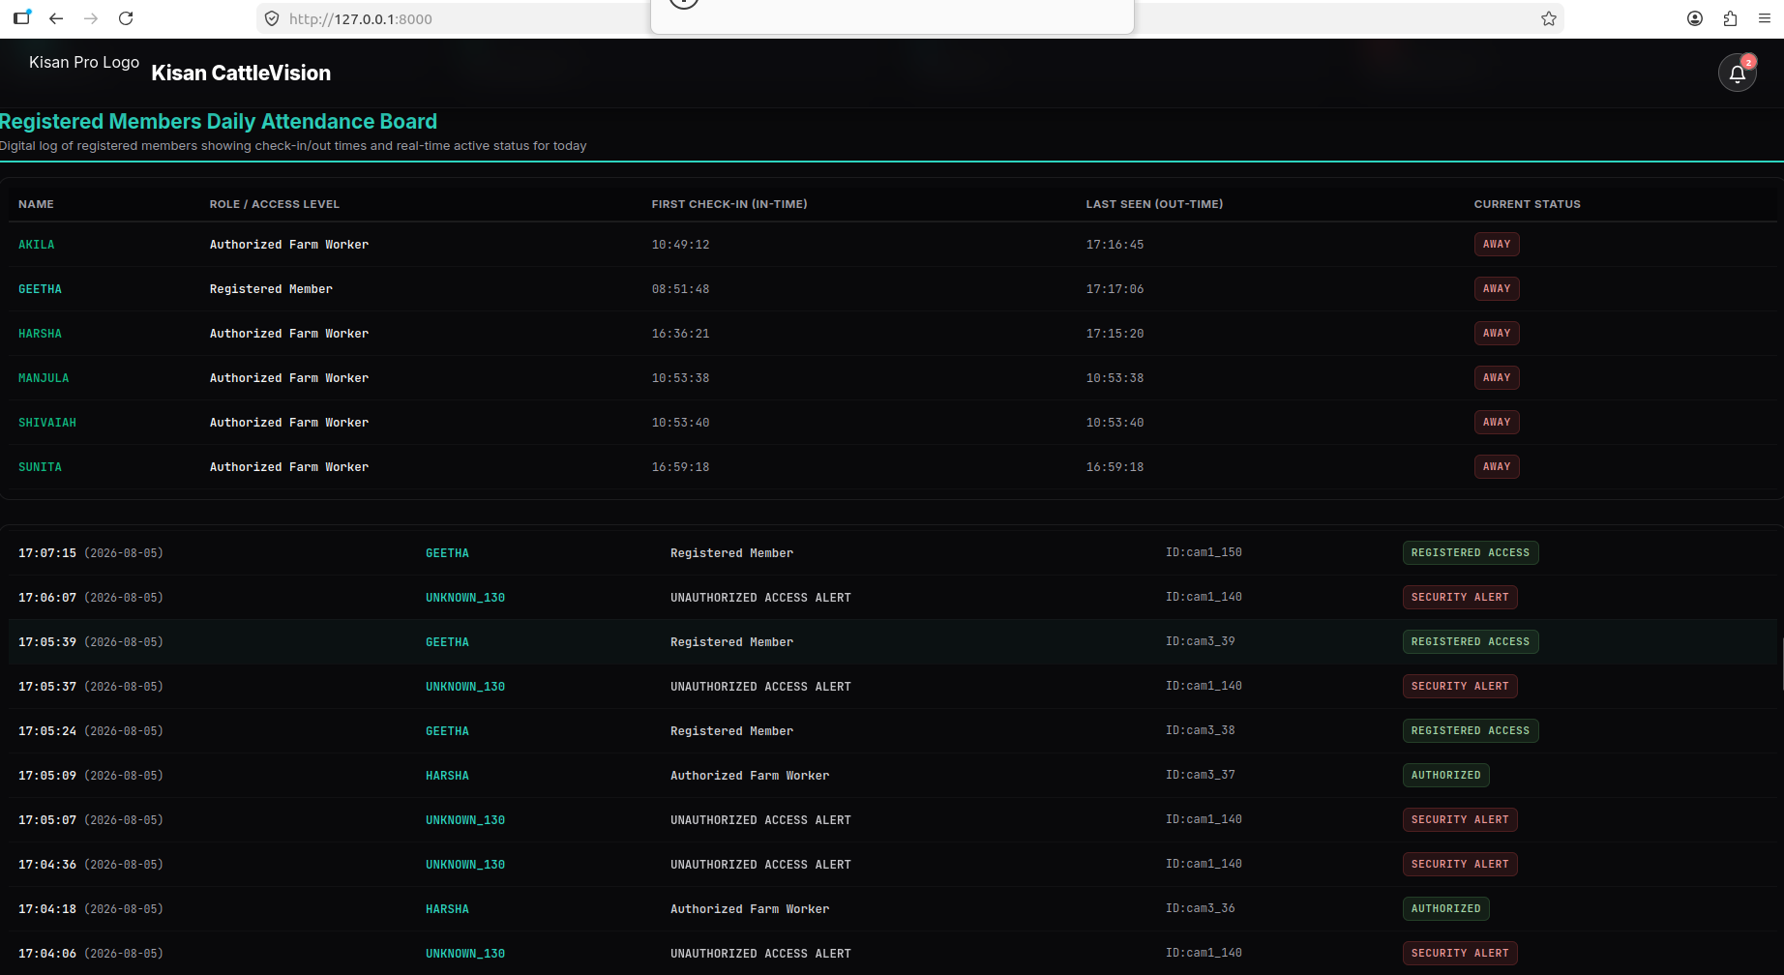
Plate 5: Live Remote Monitoring Mobile Web Dashboard Interface
The following photographic plates document the laboratory setup, real-world farm deployment, live edge re-identification inference, Telegram bot alert delivery, and live monitoring dashboards:
- Plate 1 (Figure 1): Real-World Physical Edge Hardware Deployment at Farm Entrance Gate (assets/levels/Level 3 - Field Real time Environment/Farm Deployment.jpg).
- Plate 2 (Figure 2): Real-Time Multi-Person Re-Identification & DeepSORT Tracking on Jetson Orin Nano (assets/levels/Level 1 - Lab Environment/known and unknown reidentifaction.jpeg).
- Plate 3 (Figure 3): Multi-Camera Re-Identification Pipeline Across Diverse Farm Angles (assets/levels/Level 2 - Lab Real time Environment/Person reidentification with multi camera .jpeg).
- Plate 4 (Figure 4): Instant Telegram Notification Bot (Kisan_pro_cattle_monitor_bot) Event-Driven Photo Delivery (assets/levels/Level 1 - Lab Environment/Alert to Telegram.jpg).
- Plate 5 (Figure 5): Live Remote Monitoring Mobile Web Dashboard Interface (assets/levels/Level 1 - Lab Environment/DASHBOARD.png).

